◆ ◆ ◆
SYSTEM REQUIREMENTS DOCUMENT
AI-Based Road Hazard Detection
and Navigation System

Project: AI-Based Speed Bump and Pothole Detection

Document Type | System Requirements Specification
Platform | Flutter (Android) + Python / FastAPI Backend
Status | Baseline for team-wide development
◆ ◆ ◆

1. Project Idea and Problem Statement

§ Project Idea
A mobile navigation application that uses smartphone accelerometer, gyroscope, GPS, and an on-device AI model to detect potential speed bumps. The application displays verified hazards on the map, warns drivers before reaching them, and allows users to submit text or voice reports.
The system shares hazard information between users through a backend and spatial database. Navigation and hazard warnings update according to the vehicle's current location and direction.
The application does not use a camera or require additional hardware.

§ Problem
Drivers may encounter speed bumps and potholes without sufficient warning. This can cause unexpected vehicle shocks, sudden braking, discomfort, and potential vehicle damage. The project aims to improve driver awareness by detecting hazards and sharing their locations.

2. Scope of the Project

§ In Scope
- Mobile navigation to a destination.
- On-device AI-based hazard detection using phone sensors.
- Dynamic hazard markers and audio warnings.
- Text and voice-based user reports.
- Backend storage, verification, and sharing of hazard information.
- Authentication, authorization, and role-based access control.
- Background sensor collection during a driving session, subject to Android permissions and restrictions.

§ Out of Scope
- Camera-based detection.
- Dedicated vehicle hardware.
- Building a new map service from scratch.
- Guaranteeing detection of every road hazard.

3. Core Features
The system has four core features.

§ Feature 1: AI-Based Hazard Detection
Collect accelerometer, gyroscope, and GPS data; process sensor windows on the phone; classify potential bumps and potholes; and associate events with location and confidence information.

§ Feature 2: Navigation and Audio Warnings
Navigate to the selected destination, display relevant hazards, update hazard relevance after turns or U-turns, and provide audio warnings based on distance and detection confidence.

§ Feature 3: Shared Hazard Reports and Verification
Submit sensor detections and manual text or voice reports to the backend. Store candidate events, identify likely duplicates, combine repeated detections and confidence information, and send uncertain cases for moderator review.

§ Feature 4: Accounts and Access Control
Support email/password authentication and three roles: Driver, Moderator, and Administrator. Enforce permissions for reporting, hazard verification, and system administration.

4. System Requirements

§ Functional Requirements
ID | REQUIREMENT
FR-01 | The app shall collect accelerometer, gyroscope, and GPS data during a driving session.
FR-02 | The on-device AI model shall identify candidate road-hazard events.
FR-03 | Each candidate event shall include a timestamp, available location information, event type, and confidence score.
FR-04 | The app shall support navigation and display relevant hazard markers.
FR-05 | The app shall provide audio warnings for relevant hazards ahead.
FR-06 | Users shall be able to submit text and voice reports.
FR-07 | The backend shall store reports and manage hazard verification status.
FR-08 | The system shall share verified hazards with other users.
FR-09 | Sensor collection shall continue in the background during a supported tracking session, subject to permissions and OS restrictions.
FR-10 | Protected operations shall require authentication and appropriate authorization.

§ Non-Functional Requirements
Accuracy: Evaluate AI precision, recall, and false-positive rate.
Location: Measure the accuracy of detected hazard locations.
Reliability: Handle GPS errors and network interruptions.
Security: Protect accounts, API endpoints, and stored reports.
Maintainability: Keep code modular, readable, and documented.
Numerical performance targets will be agreed upon after initial dataset and field testing.

5. System Architecture
The system consists of four main components:
Flutter Mobile App: Navigation interface, sensor and GPS collection, background tracking, local AI integration, reports, and audio warnings.
On-Device AI: Processes sensor windows and returns predicted event type and confidence.
Backend API: Handles authentication, reports, validation, verification, and hazard retrieval.
PostgreSQL + PostGIS: Stores users, reports, hazard records, and geographic locations.

§ Architecture Flow
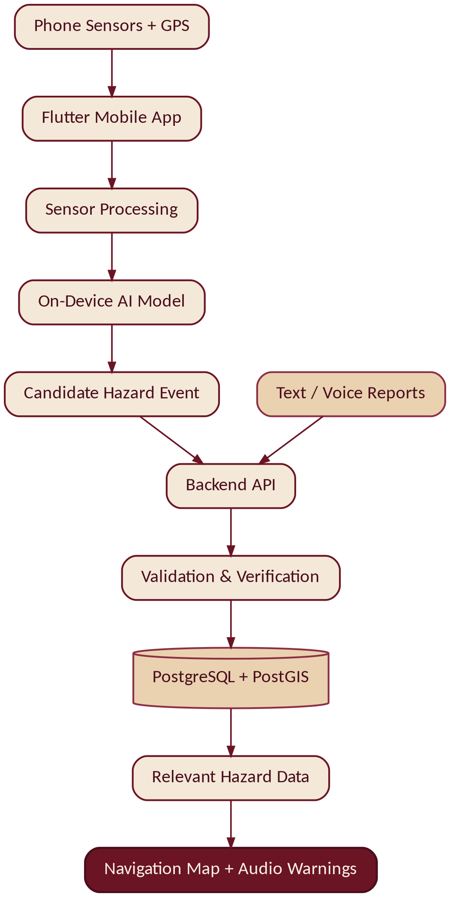
FIGURE 1 End-to-end data flow from on-device sensing to navigation and warnings.
The AI performs detection locally. The backend manages shared data and verification; it does not need to execute the model for every sensor reading.

6. System Technologies
COMPONENT | PROPOSED TECHNOLOGY
Mobile application | Flutter / Dart
Sensor collection | sensors_plus or suitable native integration
GPS and location | geolocator or Android location APIs
Background tracking | Android Foreground Service; Kotlin integration if required
Navigation and maps | Map/navigation SDK — provider to be finalized
AI development | Python, pandas, NumPy, scikit-learn
Initial AI model | Random Forest baseline, evaluated against alternatives
On-device AI | Compatible mobile inference runtime selected after model evaluation
Backend | Python / FastAPI
Database | PostgreSQL / PostGIS
API testing | Postman
Version control | Git / GitHub
Pending technology decisions: Map/navigation provider, on-device inference runtime, voice-to-text implementation, and exact package versions.

7. System Workflow
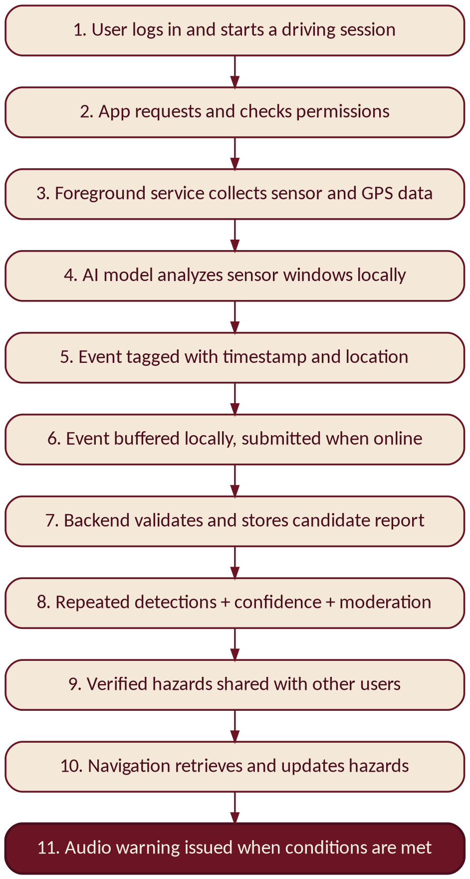
FIGURE 2 Step-by-step flow from session start to audio warning.

8. Use Case Diagram
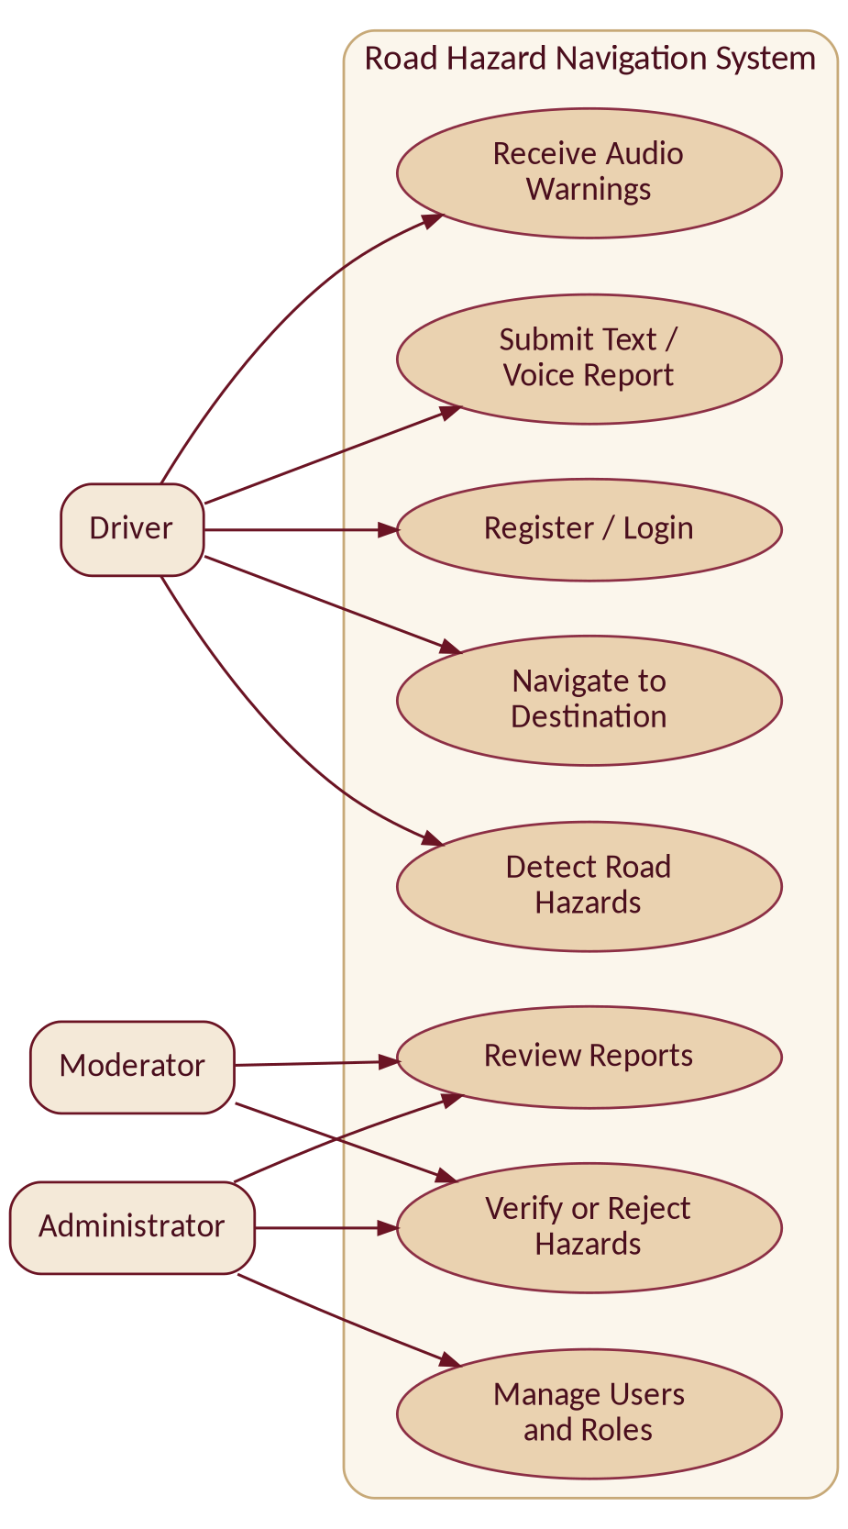
FIGURE 3 Actors (Driver, Moderator, Administrator) and their system use cases.

9. Security Requirements
- Passwords must be securely hashed, never stored as plaintext.
- Protected endpoints must require valid authentication.
- Permissions must be enforced by the backend, not only by the mobile UI.
- Users must not be able to assign themselves privileged roles.
- All reports and coordinates must be validated.
- Database queries must use safe parameterized methods.
- Secrets and tokens must not be committed to GitHub or written to logs.
- Production API traffic must use HTTPS.
- Administrative actions must be restricted and recorded.
- Location and voice data must be handled transparently and retained only as necessary.

10. Authentication and Authorization

§ Authentication
Users register and log in using email and password. The backend verifies credentials and issues an access token for protected API requests. Tokens must expire and be handled securely.

§ Authorization
The backend determines what each authenticated user can do. It checks permissions on every protected operation.
For example, a Driver may submit a report but cannot verify it. A Moderator may review and verify reports but cannot automatically manage all system roles.

11. RBAC Model
RBAC means Role-Based Access Control: users receive roles, and roles receive permissions.
OPERATION | DRIVER | MODERATOR | ADMINISTRATOR
Navigate and receive warnings | Yes | Yes | Yes
Submit text/voice reports | Yes | Yes | Yes
View verified hazards | Yes | Yes | Yes
Review and verify reports | No | Yes | Yes
Correct or deactivate hazard records | No | Limited to assigned moderation permissions | Yes
Manage users and roles | No | No | Yes
New accounts receive the Driver role by default. Role assignment and all privileged operations must be controlled by the backend.

12. RBAC Test Cases
ID | TEST | EXPECTED RESULT
RBAC-01 | Guest submits a report. | Rejected because authentication is required.
RBAC-02 | Driver submits a valid report. | Accepted if validation passes.
RBAC-03 | Driver attempts to verify a hazard. | Denied.
RBAC-04 | Moderator verifies a report. | Allowed and recorded.
RBAC-05 | Moderator attempts to assign an Administrator role. | Denied.
RBAC-06 | Administrator manages roles through an authorized operation. | Allowed and audited.

13. Threat Model
THREAT | RISK | MAIN PROTECTION
Fake hazard reports | Incorrect warnings | Validation, duplicate handling, combined verification
GPS manipulation or poor accuracy | Incorrect hazard locations | Location-quality checks and independent reports
Unauthorized access | Data exposure or misuse | Authentication and RBAC
Privilege escalation | Unauthorized administration | Server-side role checks
SQL injection | Data exposure or modification | Parameterized queries and input validation
Stolen tokens or secrets | Account or server compromise | Secure storage, HTTPS, secret management
Excessive API requests | Service disruption | Rate limiting and request limits
Incorrect AI predictions | False warnings | Labeled data, model evaluation, confidence rules

14. Security Test Cases
ID | TEST | EXPECTED RESULT
SEC-01 | Call a protected API without a token. | HTTP 401 or equivalent denial.
SEC-02 | Use an invalid or expired token. | Request rejected.
SEC-03 | Driver calls a Moderator endpoint. | HTTP 403 or equivalent denial.
SEC-04 | Register with an Administrator role. | Privileged role is not granted.
SEC-05 | Submit malformed coordinates or invalid fields. | Request rejected safely.
SEC-06 | Submit SQL-injection test input. | No unauthorized database action occurs.
SEC-07 | Inspect stored account credentials. | Passwords are hashed, not plaintext.
SEC-08 | Attempt to modify another user's protected data. | Request denied unless explicitly authorized.
SEC-09 | Repeat requests beyond the configured limit. | Rate limiting applies.
SEC-10 | Perform an authorized verification action. | Status changes and an audit record is created.

15. Decisions and Pending Items

§ Confirmed by the Team
- Full navigation to a destination.
- On-device AI inference.
- Combined hazard verification using repeated detections, confidence, and moderation of uncertain cases.
- Three roles: Driver, Moderator, Administrator.
- Email/password authentication.
- Text and voice reporting.
- Background sensor collection during an active driving session.
- No camera or additional hardware.

§ Still to Be Finalized
- Navigation/map SDK and its cost.
- AI model format and mobile inference runtime.
- Exact verification thresholds and duplicate-detection rules.
- Voice-to-text implementation.
- API endpoints and request/response formats.
- Database schema and data-retention policy.
- Numerical detection and warning performance targets.

16. Team Working Rules
- Use this document as the shared baseline.
- Agree on the database schema and API contract before integrating components.
- Keep the AI input/output format consistent with the mobile application.
- Use Git branches and pull requests for changes.
- Review and test code before merging.
- Update documentation when an agreed decision changes.
- Apply SOLID, modularity, Clean Code, and documentation principles without unnecessary overengineering.
THE GOAL Flutter, Backend, Database, and AI development all follow the same agreed requirements, interfaces, and security rules.

